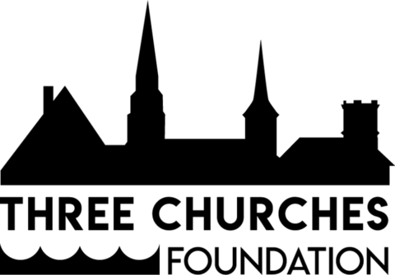

ANNUAL GENERAL MEETING
FRIDAY, 25 June, 1:00 P.M.
Via Zoom

AGENDA

1. Call to Order/Approval of Agenda

2. Approval of Minutes of October 9, 2020

3. Report of the Chair

4. Report of the Treasurer

5. Nominating Committee Report

6. Any other business

7. Adjournment

